**SKILLSOFT END-USER MARKETING RESOURCE**

**IMPORTANT: PLEASE REMOVE THIS PAGE AFTER CUSTOMIZING THE FOLLOWING PAGES**

**Step 1: Make sure you have the tools you need**.

* Locate your logo and have it ready in a file or on your desktop.
* Download fonts you'll need: Montserrat and Spectral. (Download at no cost here: <https://fonts.google.com>)

**Step 2: Insert your logo.**

* Highlight the text that says "Logo here."
* Select "Insert picture" in Word.
* Select "Picture from File" and choose your logo from the menu.
* Logo will replace text.
* Size the logo so it is no wider than 1.25 in (32 mm) and no higher than 1.5 in (38 mm).

**Step 3: Review and save as PDF.**

* Double-check all of your customizable information.
* Delete this cover sheet. (Review following steps before you do.)
* Select "File" from your Word Menu.
* Select "Save As."
* Name the document and choose a location for it.
* Select "PDF" from File Format menu.
* Click "Save."

Skillsoft CAISY™ Conversation AI Simulator

*Meet Your New Work Best Friend*

CAISY makes difficult work conversations easier by providing employees with a safe space to practice important business conversations and receive real-time, personalized feedback. You can select from a range of real-world business scenarios, like providing constructive feedback to a direct report, giving a sales pitch, talking to an upset customer, leading a product launch discussion, and a continuously growing list of others.

This new learning experience goes beyond formal training, allowing you to practice and apply your skills in relevant situations and master effective communication at work.

The platform identifies CAISY scenarios using the **AI simulator** content type, which you can find in multiple ways:

# WHERE TO FIND CAISY

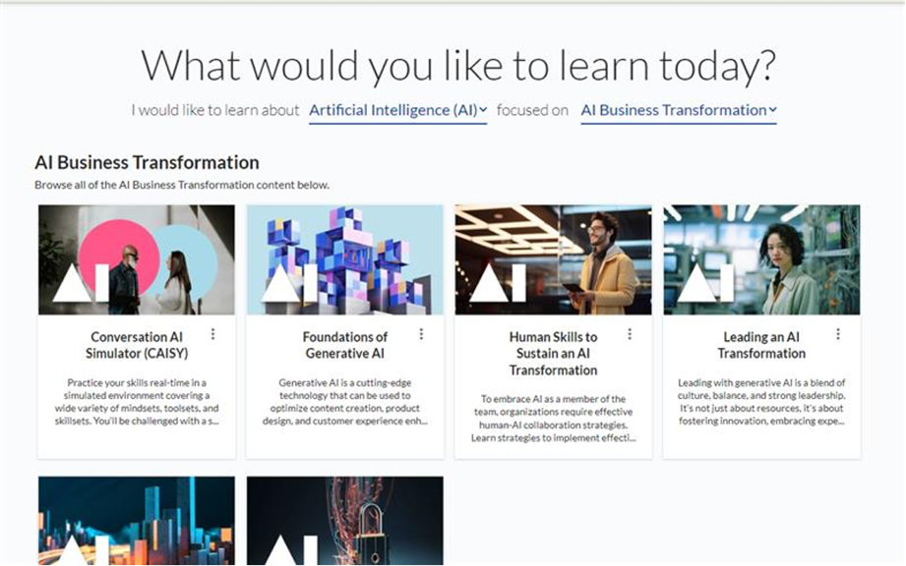

* Enter **AI simulator** in the **Search** box. The results show all CAISY content.
* Look under the **Practice** tab for AI simulator content when browsing a channel, but please note that not all channels have AI simulator content.
* If searching in general, you can use the **Type** filter, and select to show only AI simulator content if any exists for the keywords searched.
* When scanning the library, look for an area called **Artificial intelligence (AI).** Then, choose the subject **AI Business Transformation,** followed by the channel **Skillsoft's AI Simulator**.

[INSERT YOUR

ORGANIZATION’S LOGO]

Explore the diverse business conversation scenarios CAISY offers today:

**FIRST TIME PEOPLE MANAGER**

*Addressing Conflict in Your Team*

*Delegating Responsibly, Not Recklessly*

*Developing Future Leaders*

*Developing People*

*Driving for Results*

*Forming a Cross-functional Team*

*Fostering Accountability*

*Handling Difficult Conversations with Grace*

*Handling Requests for a Pay Raise*

*Managing Emotions During Crucial Conversations*

*Overcoming Hybrid Team Challenges*

*Project Management Essentials*

*Providing Constructive Feedback During Performance Reviews*

*Setting Team Goals for Productivity*

*Strategic Thinking*

**LEADERSHIP**

*Analytical & Critical Thinking*

*Avoiding Burnout in Remote Teams*

*Change Management*

*Coaching an Underperforming Employee*

*Cultivating Empathy and Connection*

*Executive Presence*

*Exploring Manager Self-Assessments*

*Giving Constructive Feedback*

*Giving Developmental Feedback*

*Giving Developmental Feedback to an Underperformer*

*Holding the Career Conversations Using the GROW Coaching Model*

*Lead the Team – Leadership Influence*

*Leading through Change*

*Making Ethical Decisions*

*Running Effective Meetings*

*Setting Professional Boundaries with Peers*

*Setting SMART Goals*

*The Creative Leader: Creative Thinking &* *Innovation*

**AGILE TECH & PRODUCT TEAMS**

*Considerations for Using AI Responsibly*

*Managing the Responsible Use of AI*

*AI Ethics and Risk*

*AI Software Requirements Planning*

*Communicating with Stakeholders when Issues Arise*

*Presenting a Product-Led Growth Strategy*

*Product Launch Decisions*

*Problem Solving after a Retrospective Meeting*

*Daily Scrum Strategy*

*Project Capacity Planning*

*Project Risk Identification*

*Investigating a Cybersecurity Breach*

*Cybersecurity Pen Testing*

*Story Telling with Data*

*Building a Data Team*

*Cloud Migration Planning*

*IT Hardware Troubleshooting*

*IT Software Troubleshooting*

*Software Project Requirements Planning*

**COACHING YOUR TEAM**

*Coaching an Employee through Career Development*

*Managing Up / Delegating Up*

**CUSTOMER SERVICE**

*Irate Customer*

*Customer Service – Refund Request*

**DEI**

*Addressing Micro-Behaviors in Team Meetings*

*Counteracting Implicit Bias in Decision Making*

*Counteracting Implicit Bias in the Hiring Process*

*Embracing Psychological Safety*

*Making Collaborative and Inclusive Decisions*

**SALES LEADERSHIP**

*Deal Inspection*

*Empowering Problem Solving Skills*

*Opportunity Review*

**SALES & MARKETING**

*PR Scandal*

*Sales Motion*

**FIRST TIME MANAGERS IN TECHNOLOGY**

*Asking Open-Ended Questions for Tech Managers*

*Managing and Delegating Up for Tech Managers*

*Negotiating with Stakeholders for Resources for Tech Managers*

*Presenting to Customers for Tech Managers*

*Tempering Stakeholder Expectations for Tech Managers*

**WELL-BEING**

*Connecting with Empathy and Authenticity*

*Making Time for Wellness through Delegation*

*Managing Multiple Priorities and Your Time Effectively*

**PROCUREMENT**

*Procurement Negotiations*

**For more information contact:**  
<Jane Doe> or email <Jane.Doe@skillsoft.com>

**Meet CAISY Today:** http://<sitename>.percipio.com